[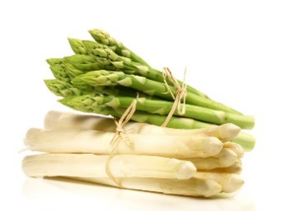](http://www.google.nl/url?sa=i&rct=j&q=&esrc=s&source=images&cd=&cad=rja&uact=8&ved=0ahUKEwjapI29hvLKAhWElQ4KHWiFBuUQjRwIBw&url=http://www.piushaven.nl/piushaven-asperge-proeverij-1-2-en-3-mei/&bvm=bv.114195076,d.ZWU&psig=AFQjCNH3_qCsnHpcvGU56UHheSsKFfpJ6Q&ust=1455360429969206)[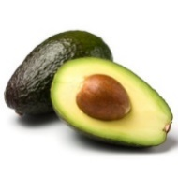](http://www.google.nl/url?sa=i&rct=j&q=&esrc=s&source=images&cd=&cad=rja&uact=8&ved=0ahUKEwj-qa77hPLKAhVEGg4KHXM3BO0QjRwIBw&url=http://www.health.com/health/gallery/0,,20554021,00.html&psig=AFQjCNGYdGirv1Erw4EoAb4nx0I6FAsR0Q&ust=1455360063878300)[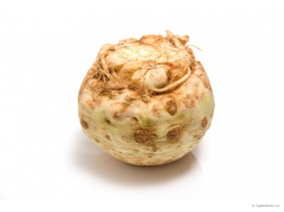](http://www.google.nl/url?sa=i&rct=j&q=&esrc=s&source=images&cd=&cad=rja&uact=8&ved=0ahUKEwiAg92YgIHLAhUHPxoKHak9BpAQjRwIBw&url=http%3A%2F%2Fwww.ingredienten.nl%2Fknolselderij&bvm=bv.114733917,d.bGQ&psig=AFQjCNHB7T_Zemt19vhz36ojmrlndZvTBw&ust=1455874196114993)

A B C

[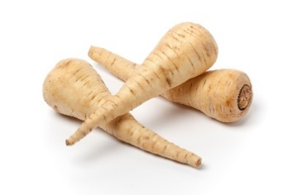](http://www.google.nl/url?sa=i&rct=j&q=&esrc=s&source=images&cd=&cad=rja&uact=8&ved=0ahUKEwidpP72_oDLAhXMvRoKHSNcDkQQjRwIBw&url=http%3A%2F%2Finnerwave.nl%2Fportfolio-item%2Fvergeten-groenten-pastinaak%2F&bvm=bv.114733917,d.bGQ&psig=AFQjCNF5QDbqS5ai2X6KpKqh4iXtx6lzAQ&ust=1455873863082119)[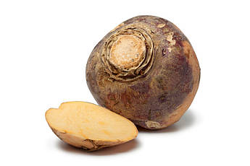](http://www.google.nl/url?sa=i&rct=j&q=&esrc=s&source=images&cd=&cad=rja&uact=8&ved=0ahUKEwjC9vzi_oDLAhXDVxoKHRovDzIQjRwIBw&url=http%3A%2F%2Fwww.puurgezond.nl%2Fvragen%2Fdurftevragen%2Fdurftevragen%2Farticle%2Fwat-is-het-verschil-tussen-koolraap-en-koolrabi%2F&bvm=bv.114733917,d.bGQ&psig=AFQjCNGGSZA7SlQEF26garfE-a_SegZcEA&ust=1455873811857016) [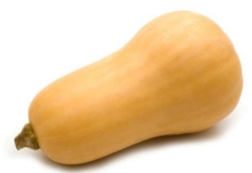](http://www.google.nl/url?sa=i&rct=j&q=&esrc=s&source=images&cd=&cad=rja&uact=8&ved=0ahUKEwia5Zi_gIHLAhXItBoKHb-IBcEQjRwIBw&url=http%3A%2F%2Fwww.madelen.nl%2Frecepten%2FInformatie.html&bvm=bv.114733917,d.bGQ&psig=AFQjCNHlQ444UxMytm0lJJzltUqok_mrqg&ust=1455874272354539)  
 D E F  
  
  
[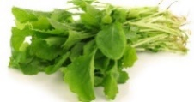](http://www.google.nl/url?sa=i&rct=j&q=&esrc=s&source=images&cd=&cad=rja&uact=8&ved=0ahUKEwjdwIa4_4DLAhVIOBoKHfj4D2UQjRwIBw&url=http%3A%2F%2Fwww.vullenofvoeden.nl%2Fgroentje%2Fraapstelen%2F&bvm=bv.114733917,d.bGQ&psig=AFQjCNFsZaqmeANvpDNBwe3AuR-NTUxsoA&ust=1455873981226631) [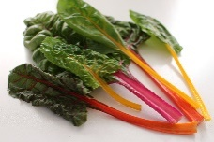](https://www.google.nl/url?sa=i&rct=j&q=&esrc=s&source=images&cd=&cad=rja&uact=8&ved=0ahUKEwjmyMrY_4DLAhWHOhoKHQpfD6AQjRwIBw&url=https%3A%2F%2Fslimvitaal.nl%2Fsnijbiet-biet-en-geitenkaas%2F&bvm=bv.114733917,d.bGQ&psig=AFQjCNG9eXXB-LAu0znBjXHEAcRIO2R1Rg&ust=1455874051499068) [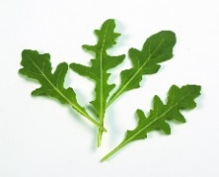](http://www.google.nl/url?sa=i&rct=j&q=&esrc=s&source=images&cd=&cad=rja&uact=8&ved=0ahUKEwjw6enWhfLKAhWG-g4KHfVmAzkQjRwIBw&url=http://www.verseoogst.nl/producten/rucola/&bvm=bv.114195076,d.ZWU&psig=AFQjCNGgpvRCIfH8Fb6sL4aH7B2LI1TCjg&ust=1455360270097568)  
   
 G H I  
  
  
[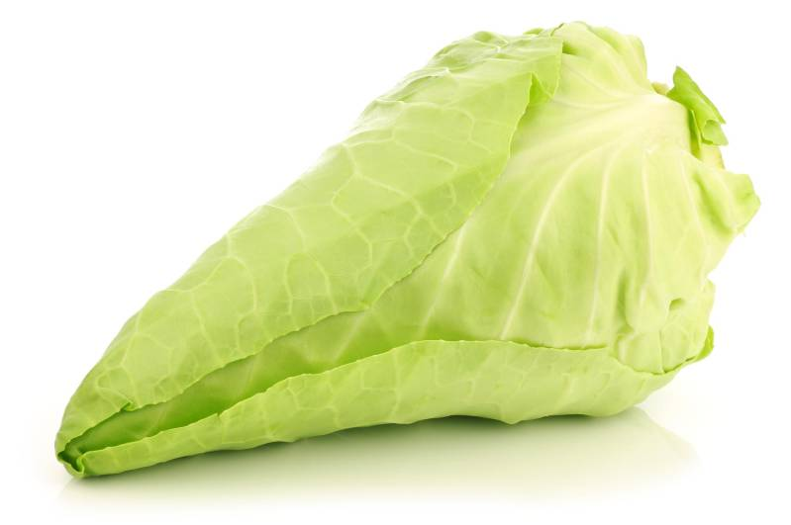](http://www.google.nl/url?sa=i&rct=j&q=&esrc=s&source=images&cd=&cad=rja&uact=8&ved=0ahUKEwibjr-MgYHLAhUK7hoKHVfsBOwQjRwIBw&url=http%3A%2F%2Fwww.hoelangmoethetkoken.nl%2Fspitskool-koken%2F&bvm=bv.114733917,d.bGQ&psig=AFQjCNHztwdkrUS-32ASTFw96cw65qr4BA&ust=1455874441028966)[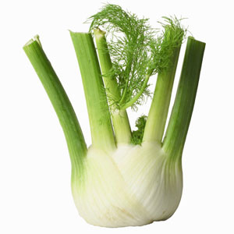](http://www.google.nl/url?sa=i&rct=j&q=&esrc=s&source=images&cd=&cad=rja&uact=8&ved=0ahUKEwiGhM2shfLKAhVHYQ4KHcOnC_AQjRwIBw&url=http://www.vital24.nl/groentenschotel-met-wortel-venkel-courgette-en-zoete-aardappel/&bvm=bv.114195076,d.ZWU&psig=AFQjCNHkY_B2RYOT4PsIpY9NY-FTp-EVNg&ust=1455360181594721)[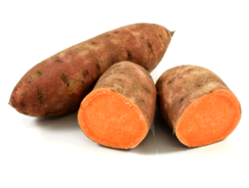](http://www.google.nl/url?sa=i&rct=j&q=&esrc=s&source=images&cd=&cad=rja&uact=8&ved=0ahUKEwi-xpjlgIHLAhXJmBoKHf81ALUQjRwIBw&url=http%3A%2F%2Fgavimensch.blogspot.com%2F2013%2F08%2F3-recepten-met-bataten.html&bvm=bv.114733917,d.bGQ&psig=AFQjCNGRJiar-dQM8n-VSoJqfHTOatjwRw&ust=1455874325566311)  
  
 J K L